LAKE MARGRETHE PROPERTY OWNERS ASSOCIATION

**Membership MEETING October 9, 2010**

**9:00 A.M. – GRAYLING TOWNSHIP HALL**

Directors in attendance: Joe Porter, Chuck Spencer, Charlotte Bloomquist, Morrie Stevens, Harry Wojcik, RJ Hannan, and Marshall Roe

Directors not in attendance: Ron Herron, and Doug Dodge

Meeting called to Order at 9:00 a.m. by President Porter. Attendance: 25.

* Welcome & introductions of members & guests.
* LMPOA objectives read.

MINUTES: Motion made and seconded to approve the annual membership meeting minutes from July 10, 2010. Minutes published in Ripples & posted to web site. MOTION CARRIED.

**TREASURER’S REPORT:** Financial statements were presented & discussed by Bloomquist. Business Free Checking account balance is $9,514.11 as of October 3, 2010.

**SECRETARY’ REPORT:**

* The Ripples Is being distributed to about 90 e-mail addresses and posted the LMPOA web site.
* July elections: Herron, Hannan, and Wojcik elected to 3-year terms.
* Officers: Porter President, Spencer VP, Bloomquist, Treasurer, Roe, Secretary
* LMPOA is a member of the Grayling Regional Chamber of Commerce.
* Letter from Huron Pines thanking LMPOA for its $100 contribution and inviting members to visit their website for information about efforts to conserve and protect forests, lakes, and streams of Northeast Michigan.

**MEMBERSHIP:** Refer to attached report for a complete outline of plans reviewed in the meeting.

* 251 paid members.
* 61 former members shown as unpaid for 2010.
* Special event planning for 2011 is on track.

COMMITTEE REPORTS:

**WATER LEVEL PROJECT:**

* Spencer reviewed the history and status of the completed project four-year project to gain better control of the lake’s water level.
* Porter discussed the current status of the lake level, which has been very close the court ordered level all season. He also thanked Spencer and Stevens for their respective roles in making the project successful.

**Lake Water Level: Inches +/- Court Ordered Level @ Wall Gage**

**(Calendar Year 2009 vs. 2010)**

|  |  |
| --- | --- |
|  |  |

**MILFOIL REMEDIATION:**

* No lake bottom treatment was needed in 2010 and none may be required in 2011.
* The $400 permit required by the DEQR for lake treatment with 2-4d is not refundable or transferable to another year.
* Porter reminded the member ship that Gary McConnell will be unable to perform the function of Milfoil Chairperson after this summer.

**Water Clarity (Secchi Disk Readings)**: No report. No issues cited by members.

**Water Testing:**

* Moore reports surface water is slightly basic. No change from previous readings.
* Porter reports Phosphorus, Chlorophyll, and E-Coli testing are on schedule.

**LAKE MARGRETHE FOUNDATION FUND:** Porter reported $95,194.91 in the endowment. $400 granted for Milfoil treatment permit. See business report in the Ripples for current data.

**OLD BUSINESS**

* None

**NEW BUSINESS**

* Porter reported that the DNR (Mark Tonnello) has not planted Walleye fingerlings into the lake for another year. This is due to a concern with the spread of disease. The following quote from the DNR web site:

*“As in the past two years, the Department of Natural Resources and Environment's Fisheries Division will again produce fewer walleye fry this year than it did in the past as a precaution against spreading of viral hemorrhagic septicemia (VHS). Fisheries Division is taking precautions not to expose its hatcheries to the virus or to spread the disease to additional water bodies in the state of Michigan.”*

* However, the DNR does report that 2,000 Northern Muskellunge were planted in Lake Margrethe in 2010. This brings the total to about 10,000 Muskie’s being planted in Lake Margrethe in the past few years.

MEMBER COMMUNICATION

Sandra Michalik, of Eagle Point, provided a step by step outline of how she and her husband installed a Coconut Log seawall at their lake front home on Lake Margrethe. The DEQ approved this unique approach to renewing and protecting the natural beauty of the beach and shoreline. The logs are purchased in 10’ length and installed so that the natural plant growth occurs while protecting from beach erosion. Please refer to our web site for photographs of the project.

The following statement from the DEQ web site suggests that typical vertical seawalls are being discouraged and will be replaced by more natural barriers as described by Sandra.

*“Because of these negative effects of vertical walls the DEQ recommends the use of natural shoreline treatments. New shoreline hardening should be avoided where alternate approaches such as plantings and natural stone can be used to protect property from erosion. The purpose and benefits of plantings/stone are to provide a natural transition between the open water and upland, while providing habitat.”*

ADJOURN: There being no further business, the meeting adjourned at 10:20 am.

Respectfully submitted,

Marshall Roe

Secretary

Attachment: 2011 Membership Plans approved by the Board.

`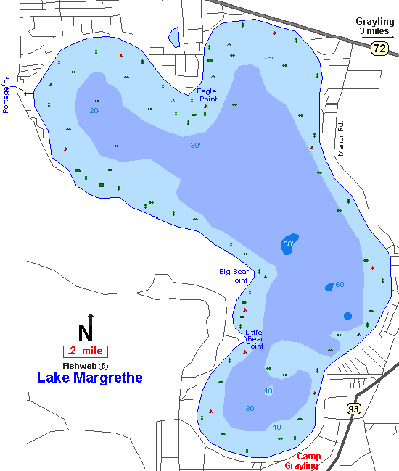

LMPOA Membership Committee

The goal of the committee is to increase membership in the association through involving property owners and families in activities and events that showcase the importance and fun of being part of the LMPOA.

# *October 9, 2010*

# Report – RJ Hannan, Membership Chair

* We are completing solicitation for 2010 membership by personal contact with a number of stragglers and those who may have lost interest in the association for seemly minor issues. This effort has resulted in about 12 new or renewed memberships.
* The coming summer season should be a turnaround year in which the association once again grows its membership. Three new programs should contribute significantly toward this goal:
  + **Social Event** - A dinner show at the Camp Grayling Officers Club on May 21 will kick off the summer season in a big way with 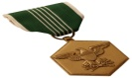Michigan Singers, celebrating Armed Forces Day. A cash bar and complete dinner will start the evening festivities. Initially, tickets will be distributed via various means to only active LMPOA members (limit 2 per household) at a special member-only price. After March 15, any remaining tickets may be purchased by members or friends of LMPOA at the regular price. Due to a limited number of tickets being available, members are urged to renew membership and order tickets now!
  + **Fishing Derby** – Plans are underway to conduct a special Fishing Derby on the weekend C:\Documents and Settings\Marshall\Local Settings\Temporary Internet Files\Content.IE5\768MG6LR\MC900354899[1].wmfof June 11-12. Lynn Toma of the DNRE fisheries division is very supportive of the effort and promises to include it on the state calendar of events. Informational material also will be distributed, if available. Further, we were advised that here are no special state requirements for sponsors of such an event. Board and membership involvement is now needed to carry out the fun day.
  + **The Store -** An important element in this growth-year effort is the “Lake Margrethe Store.” Your LMPOA membership card will be the key to great discounts on insignia items proudly showing commitment to the Lake Margrethe community. North Country Corner in Grayling has agreed to be the central point for apparel items, as well as gifts. A variety of merchandise will soon be available (some already in stock). The LMPOA web site and the store will display items. Stay tuned for more information.

## Every property owner will discover that membership in LMPOA has perks along with the importance of maintaining the vitality of our beautiful lake.